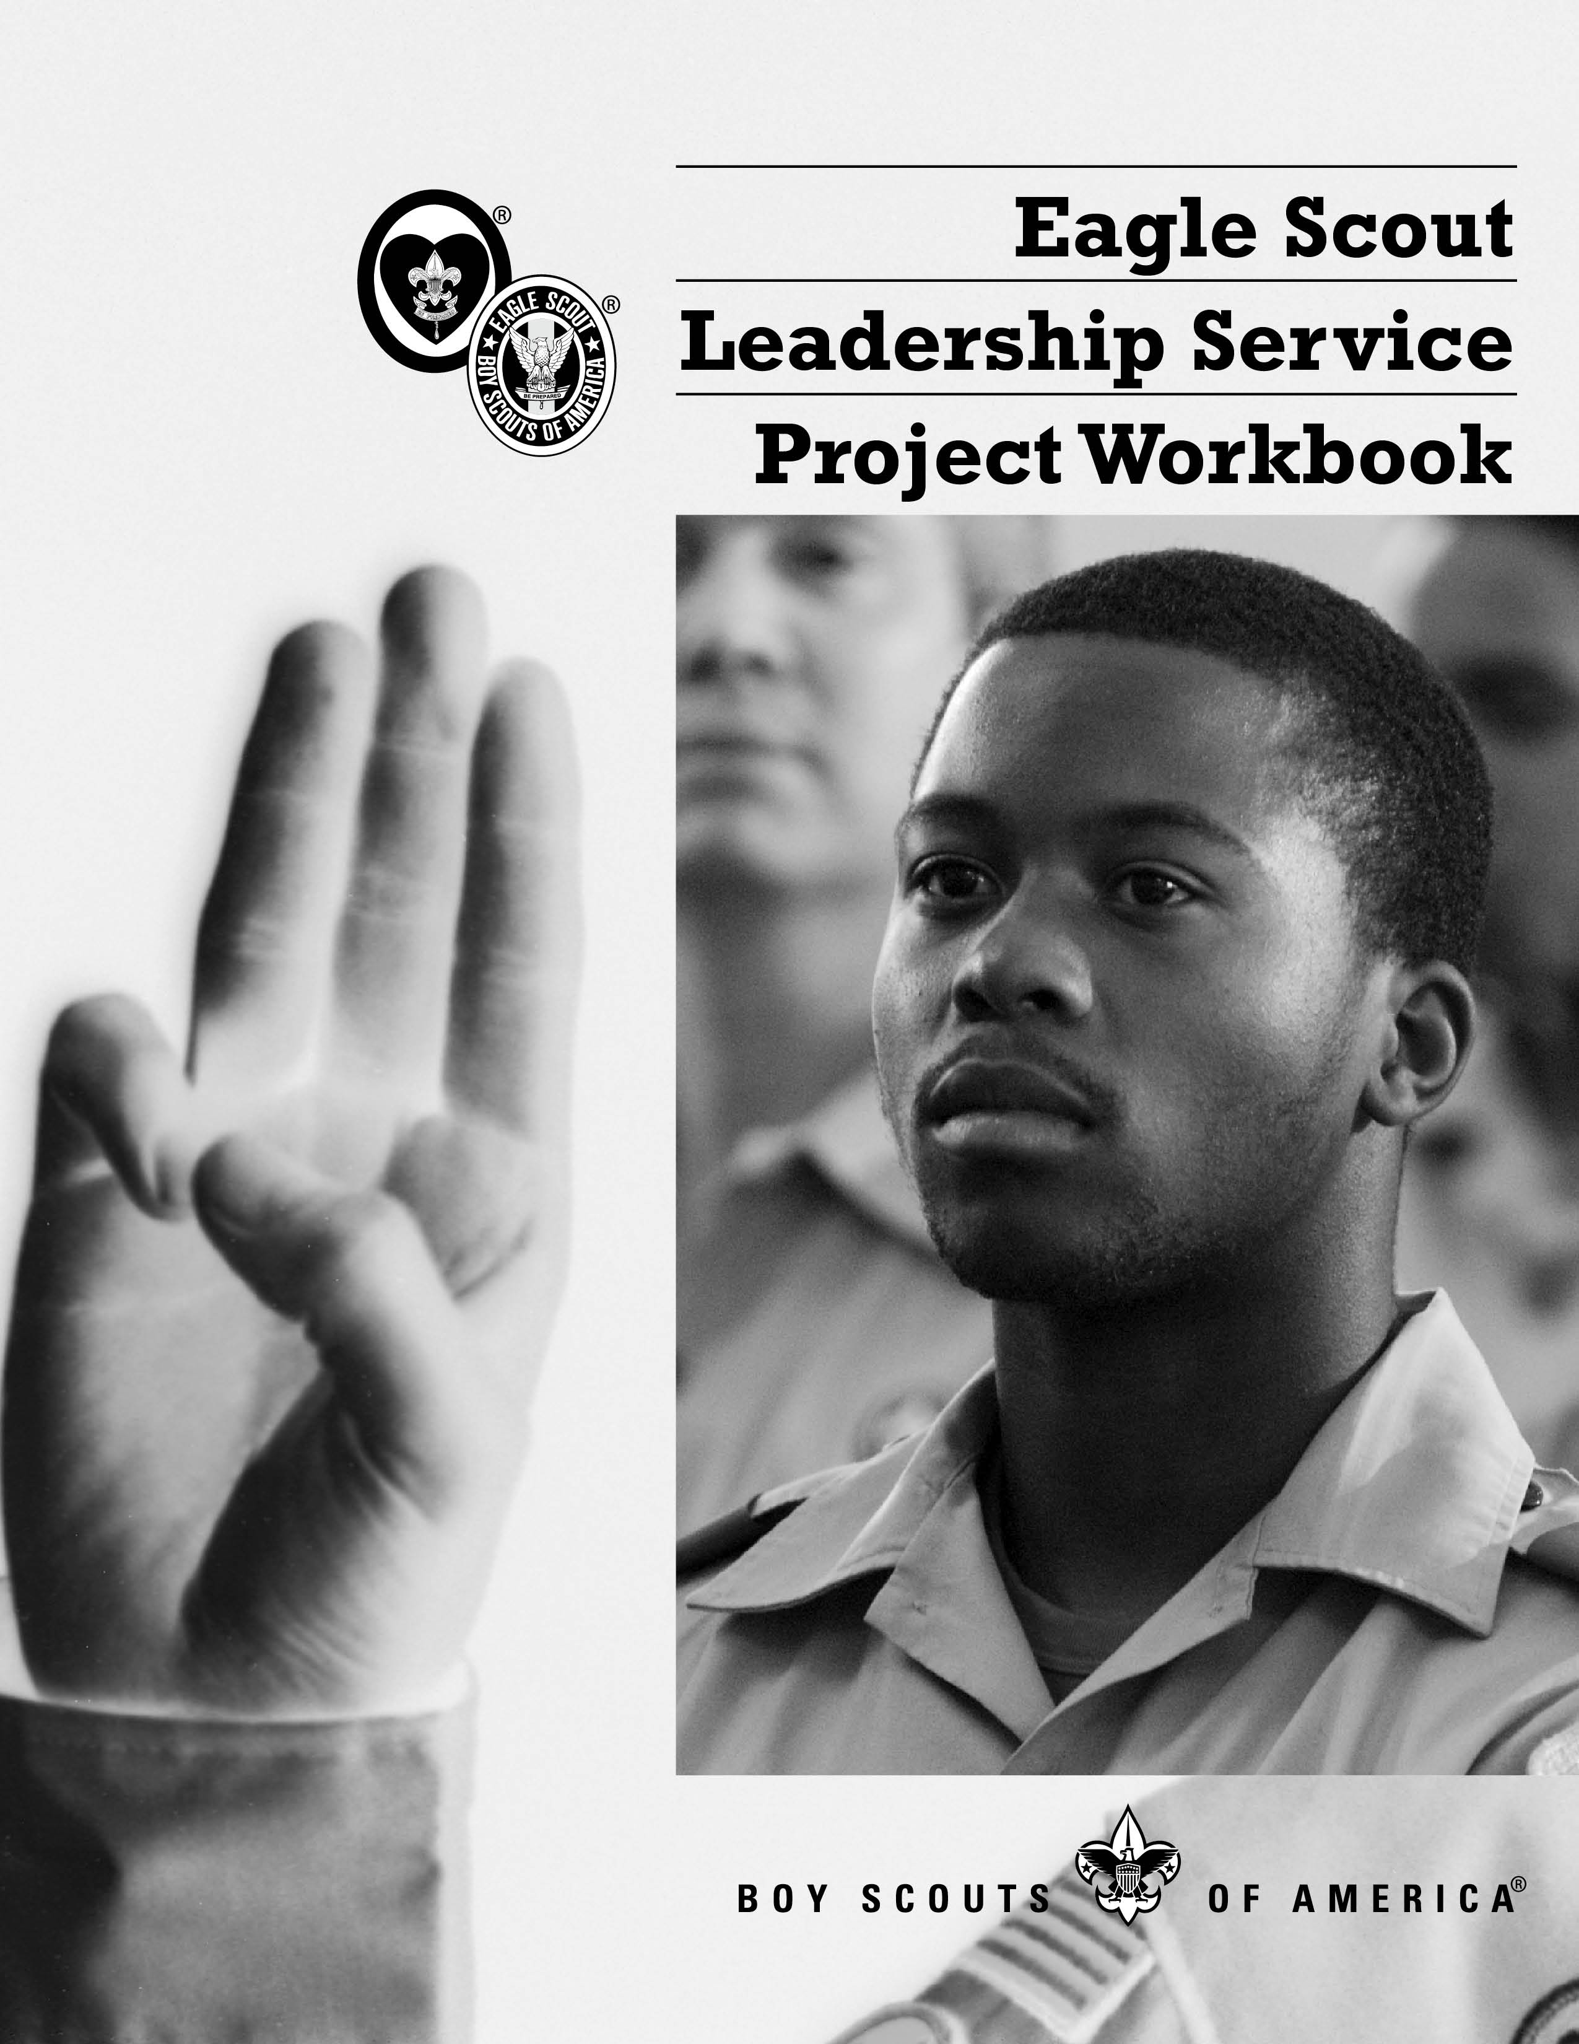



Message from the

Chief Scout Executive

Congratulations, Life Scout.

In attaining the rank of Life Scout, you have had the opportunity to learn and master many skills. You’ve hiked and camped in good and not-so-good weather. You’ve learned to take care of yourself and others in the out-of-doors, as well as in your home community.

Before you now is the opportunity to master yet another set of skills. These skills are encompassed in the requirements for the rank of Eagle Scout. One of these requirements is your demonstration of leadership skills. You do so by planning and carrying out an Eagle Scout leadership service project.

This Eagle Scout Leadership Service Project Workbook will help you meet this requirement. You will use this workbook to plan, receive the necessary approvals, carry out, and then report on the completion of your project.

After completing your project and all the other requirements for the rank of Eagle Scout, complete the following steps:

Review the Eagle Scout Rank Application. Note that you will need to list references of people who will speak on your behalf. You will also need to prepare a statement about yourself.

Fill out the Eagle Scout Rank Application. Ask your unit leader and/or unit advancement committee person to assist you.

Secure the signatures of your unit leader and unit committee chairman. Their signatures indicate approval and recommendation by your unit.

Submit your Eagle Scout Rank Application and the statement about yourself with your Leadership Service Project Workbook to your local council service center.

The contents of your application will be certified and the references you have listed will be contacted. After certification and reference verification, you will be contacted by the Eagle Scout board of review chairman, who will set your board of review date.

Eagle Scouts are recognized as a group of men who are outstanding in all that Scouting represents. I encourage you to become a member of this elite group.

Sincerely,

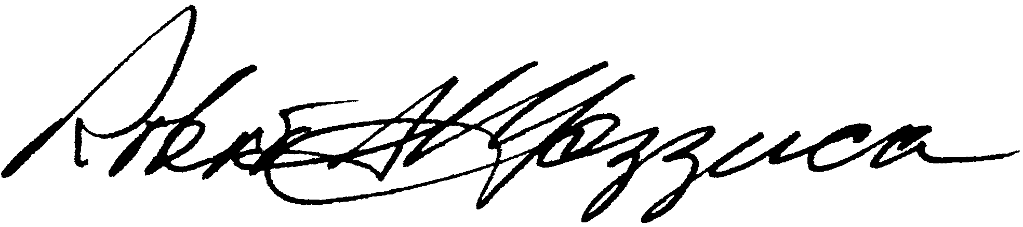

Robert J. Mazzuca

Chief Scout Executive

Eagle Scout Leadership Service Project Workbook

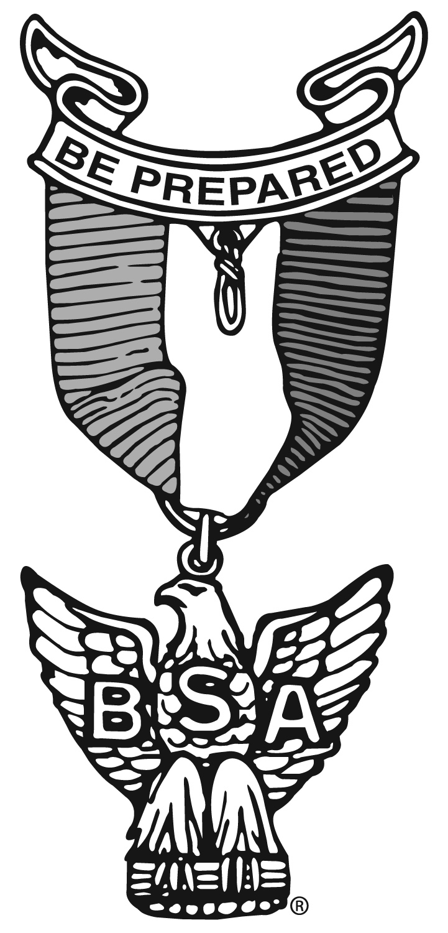 | Scout’s name  Address  Telephone No. Date of birth  E-mail (optional)  Unit No.  District  Local council  Unit leader’s name  Address  Telephone No.  Unit advancement committee person’s name  Address  Telephone No.

Your Eagle Scout Leadership Service Project

How to Start

You have earned the Life Scout rank and are ready to begin your Eagle Scout leadership service project. This workbook will help you plan and record your progress and complete and submit a final report.

The Requirement

As stated in the Boy Scout Handbook: While a Life Scout, plan, develop, and give leadership to others in a service project helpful to your religious institution, school, or your community. (The project should benefit an organization other than the BSA.) The project plan must be approved by the organization benefiting from the effort, your unit leader (Scoutmaster, Varsity Scout Coach, Venturing crew Advisor), unit committee, and by the council or district advancement committee before you start. You must use the Eagle Scout Leadership Service Project Workbook, No. 18-927E, or this online equivalent, in meeting this requirement.

Originality

Does the leadership service project for Eagle have to be original, perhaps something you dream up that has never been done before? The answer: No, but it certainly could be. You may pick a project that has been done before, but you must accept responsibility for planning, directing, and following through to its successful completion.

Limitations

- Routine labor (a job or service normally rendered) should not be considered.
- Projects involving council property or other BSA activities are not acceptable.
- Projects may not be performed for businesses.
- Projects may not be of a commercial nature.
- Projects may not be a fund-raiser. Fund-raising is permitted only for securing materials needed to carry out the project.
- Donors to projects must be made aware of what entity is benefiting from the project, and that it clearly is not the Boy Scouts of America.
- Any funds raised for a project and not used for the purchase of project materials must be returned to the donors.

Size

How big a project is required? There are no specific requirements, as long as the project is helpful to a religious institution, school, or community. The amount of time spent by you in planning your project and the actual working time spent in carrying out the project should be as much as is necessary for you to demonstrate your leadership of others.

Examples

A look at some projects other Scouts have done for their Eagle Scout Award illustrates that your project can be to construct something or can be to render a service. Scouts have
- Made trays to fasten to wheelchairs for veterans with disabilities at a Veterans Administration hospital.
- Collected used books and distributed them to people in the community who wanted and needed, but could not afford, books.
- Built a sturdy footbridge across a brook to make a safe shortcut for children between their homes and school.
- Collected and repaired used toys and gave them to a home for children with disabilities.
- Organized and operated a bicycle safety campaign. This involved a written safety test, equipment safety check, and a skills contest in a bike rodeo.
- Surveyed the remains of an old Spanish mission and prepared an accurate map relating it to the present church.
- Built a “tot lot” in a big city neighborhood and set up a schedule for Boy Scouts to help run it.
- Set up a community study center for children who needed a place to do schoolwork.
- Trained fellow students as audiovisual aides for their school. Arranged for more than 200 hours of audiovisual work.
- Prepared plans for a footbridge on a trail in a national forest. Worked with rangers to learn the skills necessary to build the structure, gathered materials and tools, and then directed a Scout work group to do the construction.

Approvals

Before You Start

The project plan must be reviewed and approved by the beneficiary of the project, your unit leader, the unit committee, and the council or district advancement committee before the project is started. The following questions must be answered before giving this approval:
- What is the project you are planning?
- Who will benefit from the project?
- How will they benefit?
- What representative of the project’s beneficiary will be contacted for guidance in planning the project?
- What are the project planning details?

Remember, the project must be approved before you begin, so make sure all signatures have been secured before you start the project. You must be a Life Scout before you begin an Eagle Scout leadership service project.

After Completion

Although your project was preapproved by the project’s beneficiary, your unit leader, the unit committee, and the council or district advancement committee before it was begun, the Eagle
Scout board of review must approve the manner in which it was carried out. The following must
be answered:
- In what ways did you demonstrate leadership of others?
- Give examples of how you directed the project rather than doing the work yourself.
- In what way did the religious institution, school, or community group benefit from the project?
- Did the project follow the plan?
- If changes to the plan were made, explain why the changes were necessary.

Filling Out the Form

As you plan and carry out your leadership service project, use this workbook to record your plans and progress. Remember that others will be reading these pages. You should print, type, or write legibly using black or blue ink. Complete the form on a computer if you have access to an electronic version. You may add as many pages as needed to thoroughly complete the workbook.

National Eagle Scout Association

The National Eagle Scout Association was created in 1972 with the express purpose of bringing together Eagle Scouts of all ages so that they may be of greater service to themselves, their local councils, and their communities, thereby conserving and developing the human resources potential represented by those who hold Scouting’s highest rank.

When you receive your Eagle badge, you will be eligible for membership in this elite association. You should give it serious consideration. Applications are available from your local council service center.

Project Description

Project name:

Describe the project you plan to do.

(This box may be adjusted to fit your description.)

What group will benefit from the project?

Name of religious institution, school, or community Telephone No.

Street address City State Zip code

My project will be of benefit to the group because:

(This box may be adjusted to fit your description.)

This concept was discussed with my unit leader on: | Date

The project concept was discussed with the following representative of the group that will benefit from the project.

 | Representative’s name | Date of meeting
 | Representative’s title | Phone No.

Project Details

Plan your work by describing the present condition, the method, materials to be used, project helpers, and
a time schedule for carrying out the project, the estimated cost of the project, and how the needed funds will
be obtained. Describe any safety hazards you might face, and explain how you will ensure the safety of those carrying out the project.

If appropriate, include photographs of the area before you begin your project. Providing before-and-after photographs of your project area can give a clear example of your effort.

(This box may be adjusted to fit your description.)
“Before” Photographs

Approval Signatures for Project Plan

Project plans were reviewed and approved by:
Religious institution, school, or community representative Date | Scoutmaster/Coach/Advisor Date
Unit committee member Date | Council or district advancement committee member Date

Important Note: You may proceed with your leadership service project only when you have:
Completed all the above mentioned planning details
Shared the project plans with the appropriate persons
Obtained approval from the appropriate persons
Carrying Out the Project

Record the progress of your project. Keep a record of how much time you spend planning and carrying out the project. List who besides yourself worked on the project, the days they worked, the number of hours they worked each day, and the total length of time others assisted on the project.

If appropriate, list the type and cost of any materials required to complete the project. If your original project plan changes at any time, be sure to document what the change was and the reason for the change.

Hours I Spent Working on the Project

The length of time spent should be as adequate as is necessary for you to demonstrate your leadership of two or more individuals in planning and carrying out your project.

Hours I spent:

Planning the project:
Carrying out the project:
Total hours I spent working on the project:

Hours Spent by Scouts, Venturers, or Other Individuals Working on the Project

Name | Date (mm/dd/yy) | No. of Hours

Total number of hours others worked on the project: _____________

For a grand total, add the total number of hours you spent on the project to the total number of hours others worked on the project: ______________
Materials Required to Complete the Project

Type of Material | Cost of Material

Changes

List any changes made to the original project plan and explain why those changes were made.

(This box may be adjusted to fit your description.)
“After” Photographs

Including photographs of your completed project (along with the “before” photographs) helps present a clearer overall understanding of your effort.

Approvals for Completed Project

Start date of project: Completion date of project :

The project was started and has been completed since I received the Life Scout rank, and is respectfully submitted for consideration.
Applicant's signature | Date

This project was planned, developed, and carried out by the candidate.
Signature of Scoutmaster/Coach/Advisor | Date
Signature of the representative of religious institution, school, or community | Date
The 12 Steps From Life to Eagle

The following 12 steps have been outlined to ensure a smooth procedure for the Scout, the unit leadership, the local council, and the volunteers
who are to conduct the board of review. Eagle candidates should share these steps with their unit leader so that they can fully understand the procedures that must be followed.

- In order to advance to the rank of Eagle, a candidate must complete
all requirements of tenure; Scout spirit; merit badges; positions of responsibility; while a Life Scout, plan, develop, and provide leadership to others in a service project; and the Scoutmaster conference.

- Using the Eagle Scout Leadership Service Project Workbook, the candidate must select his Eagle service project and have the project concept approved by his unit leader, his unit committee, and the benefactor of the project, and reviewed and approved by the council
or district advancement committee. This workbook must be used in meeting this requirement.

- It is imperative that all requirements for the Eagle Scout rank except the board of review be completed prior to the candidate’s 18th birthday. When all requirements except the board of review for the rank of Eagle, including the leadership service project, have been completed, the Eagle Scout Rank Application must be completed and sent to the council service center promptly. (Youth members with disabilities should meet with their unit leader regarding time extensions.)

- The application should be signed by the unit leader at the proper place. The unit committee reviews and approves the record of the Eagle candidate before the application is submitted to the local council.
If a unit leader or unit committee fails to sign or otherwise approve
an application, the Eagle candidate may still be granted a board of review. The failure of a unit leader or unit committee to sign an application may be considered by the board of review in determining
the qualification of the Eagle candidate.

- When the completed application is received at the council service
center, its contents will be verified and the references contacted. The council advancement committee or its designee contacts the person listed as a reference on the Eagle Scout Rank Application either by letter, form, or telephone checklist. The council determines the method or methods to be used. The candidate should have contacted those individuals listed as references before including their names on the application. The candidates should not be involved personally in transmitting any correspondence between persons listed as references and the council service center.

- The Eagle Scout Leadership Service Project Workbook, properly filled out, must be submitted with the application.

- After the contents of an application have been verified and appropriately signed, the application, Eagle Scout Leadership Service Project Workbook, and references will be returned from the council service center to the chairman of the Eagle board of review so that a board of review may be scheduled. Under no circumstances should a board of review be scheduled until the application is returned to the chairman of the Eagle board of review. Reference checks that are forwarded with the application are confidential, and their contents are not to be disclosed to any person who is not a member of the board of review.

- The board of review for an Eagle candidate is composed of at least
three but not more than six members. One member serves as chairman. Unit leaders, assistant unit leaders, relatives, or guardians may not serve as members of a Scout’s board of review. The board of review members should convene at least 30 minutes before the candidate appears in
order to review the application, reference checks, and leadership
service project report. At least one district or council advancement representative must be a member of the Eagle board of review if the board of review is conducted on a unit level. A council or district may designate more than one person to serve as a member of Eagle boards
of review when requested to do so by the unit. It is not required
that these persons be members of the advancement committee; however, they must have an understanding of the importance
of the Eagle board of review.

- The candidate’s unit leader introduces him to the members of
the board of review. The unit leader may remain in the room, but does not participate in the board of review. The unit leader may
be called on to clarify a point in question. In no case should a relative or guardian of the candidate attend the review, even as a unit leader. There is no set of questions that an Eagle candidate should be asked. However, the board should be assured of the candidate’s participation in the program. This is the highest award that a Scout may achieve and, consequently, a thorough discussion of his successes and experiences in Scouting should be considered. After the review, the candidate and his unit leader leave the room while the board members discuss the acceptability of the candidate as an Eagle Scout. The decision must be unanimous. If the candidate meets the requirements, he is asked to return and is informed that he will receive the board’s recommendation for the Eagle Scout rank. If the candidate does not meet the requirements, he is asked to return and told the reasons for his failure to qualify. A discussion should be held with him as to how he may meet the requirements within a given period. Should the applicant disagree with the decision, the appeal procedures should be explained to him. A follow-up letter must be sent to the Scout confirming
the agreements reached on the action(s) necessary for the advancement. If the Scout chooses to appeal, the board should provide the name and address of the person he is to contact.
(See “Appealing a Decision” in the National BSA Policies
and Procedures, No. 33088D.)

- Immediately after the board of review and after the application
has been appropriately signed, the application, the service project report, references, and a properly completed Advancement Report are returned to the council service center.

- When the application arrives at the council service center, the Scout executive signs it to certify that the proper procedure has been followed and that the board of review has recommended the candidate for the Eagle Scout rank. This workbook and references are retained by the council. The workbook may be returned to the Scout after council approval.
Only the Eagle Scout Rank Application is forwarded to the national Eagle Scout Service.

- The Eagle Scout Service screens the application to ascertain information such as proper signature, positions of responsibility, tenure between ranks, and age of the candidate. Any item not meeting national standards will cause the application to be returned for more information. If the application is in order, the Scout is then certified as an Eagle Scout by the Eagle Scout Service on behalf of the National Council. Notice of approval is given by sending the Eagle Scout certificate to the local council. The date used on the certificate will be the date of the board of review. The Eagle Award must not be sold or given to any unit until after the certificate is received by the council service center. The Eagle Scout court of honor should not be scheduled until the local council receives the Eagle Scout rank credentials. After earning
the Eagle Scout Award, a Scout may work to earn Eagle Palms.
An Eagle Palm or Palms must be earned before the Scout’s 18th birthday. Palms must be earned one at a time, in the order of Bronze, Gold, and then Silver. Each Palm level can only be earned after a three-month tenure since earning the last Palm and by satisfactory completion of all of the other requirements for
the next Palm.

18-936
2008 Boy Scouts of America

